

**CANYON LAKE HAWK RELAYS**

**ORDER OF EVENTS**

**12:00** PM Scratch meeting (Field Shed behind the concession stand)

**12:30** PM

(12:30PM) 3200 JVG/VG/JVB/VB

SHOT PUT RING #1 (VB/VG)

SHOT PUT RING #2 (JVG/JVB)

DISCUS RING #1 (VG/VB)

DISCUS RING #2 (JVB/JVG)

LONG JUMP PIT # 1 (JVB/VB/VG)

TRIPLE JUMP PIT # 2 (JVG/VG/VB)

HIGH JUMP PIT #1 (VG/VB) *Opening Heights VG 4'4" VB 5'4"*

HIGH JUMP PIT #2 (JVB/JVG) *Opening Heights JVG 4'0" JVB 5'0"*

POLE VAULT PIT (VB/VG/JVB/JVG) *Opening Heights VB 10'0" VG 8'0" JVB 9'0" JVG 7'0"*

**AFTER THE 3200**

**~ 12:45 PM**

LONG JUMP PIT # 3 (JVG)

TRIPLE JUMP PIT # 3(JVB)

**2:45 PM**

BIG MAN RELAY (4x100m)

400 M RELAY JVG/VG/JVB/VB

800 M RUN JVG/VG/JVB/VB

100 M HURDLES JVG/VG

110 HURDLES JVB/VB

100 M DASH JVG/VG/JVB/VB

800 M RELAY JVG/VG/JVB/VB

400 M DASH JVG/VG/JVB/VB

300 M HURDLES JVG/VG/JVB/VB

200 M DASH JVG/VG/JVB/VB

1600 M RUN JVG/VG/JVB/VB

1600 M RELAY JVG/VG/JVB/VB

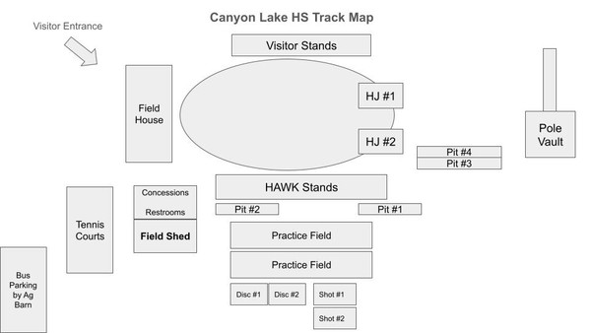

[zoom_out_map](https://cdn.smore.com/u/09a1/e6a2d3d14056cb0b95e5991c2d897852.jpeg)

**CLHS Track Map**

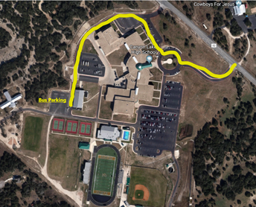

[zoom_out_map](https://cdn.smore.com/u/5a04/cd96f13791627e16be125826e61531ba.png)

**Bus Parking**

[zoom_out_map](https://cdn.smore.com/u/1d1a/c9b93631d710b6ddeb4d3bc2d665dec6.png)

**Clear Bag Policy**

**\*Under Construction\***